C0545 - Business Opportunity and Service Contract Lines

|  |  |  |  |  |
| --- | --- | --- | --- | --- |
| **Ver** | **Date** | **Author** | **Comments** | **Reviewed by** |
| 1 | 01/03/2020 | Tom Bell | CRIM 0545 - CRM | TBC |
|  |  |  |  |  |

Requirements 2

Prerequisites 2

Solution Overview 2

Solution Details 2

Security 3

Companies 3

Data Migration 3

Test Steps 3

Technical Implementation 3

Requirements

1. Custom Right Mouse Button from the Business Opportunity – create Service Contract.

2. Custom Field on Business Opportunity screen – Service Contact

3. Custom field on the Service Contract screen – Business Opportunity Reference

4. Event to move opportunity to Won when Contract is made active.

Prerequisites

<Describe any pre-requisites that this development may rely upon, data configuration or other developments>

Solution Overview

1. Custom Right Mouse Button from the Business Opportunity screen called “Create Service Contract”. When clicked it must automatically populate the Customer ID and Customer Name from the Business Opportunity screen. The event must also auto populate the below custom fields forming the link between Service Contract and Business Opportunity).
2. Custom Field on Business Opportunity screen – “Service Contact Reference”.
3. Custom field on the Service Contract screen – “Business Opportunity Reference”
4. An event must change the linked Business Opportunity to Closed as Won when a linked Service Contract ID is set to Status Active.

Solution Details

# Custom Right Mouse Button from the Business Opportunity – create Service Contract.

The below screenshot shows where the “Create Service Contract” RMB option must be available from in Business Opportunity screen. It must be below “Create Service Quotation” in the RMB list.

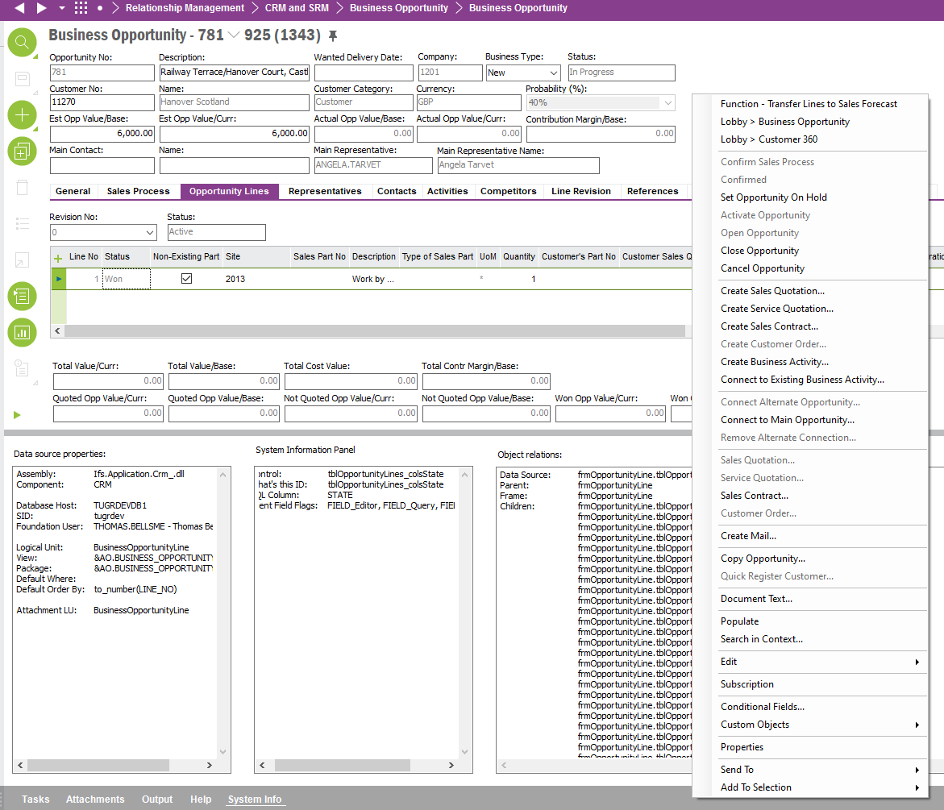

When “Create Service Contract” RMB is selected the user is brought to the Service Contract screen with the Customer No. and Customer Name field pre-populated from the Business Opportunity.

The event must also auto populate the below custom fields described in this spec (Service Contract Ref and Business Opportunity Ref) forming the link between Service Contract and Business Opportunity.

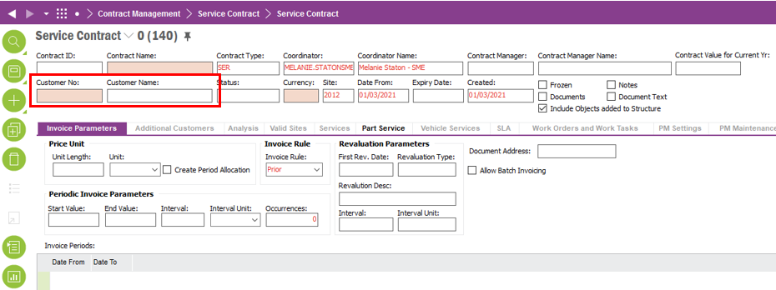

# Custom Field on Business Opportunity screen – Service Contact

A custom field containing the Service Contract ID of a linked Service Contract to the Business Opportunity should be located on the Business Opportunity Header in the top right (see red box on screenshot below).

If a Sales Contract is created from the above “Create Service Contract” RMB on the Business Opportunity screen then this field is automatically populated with the Service Contract ID.

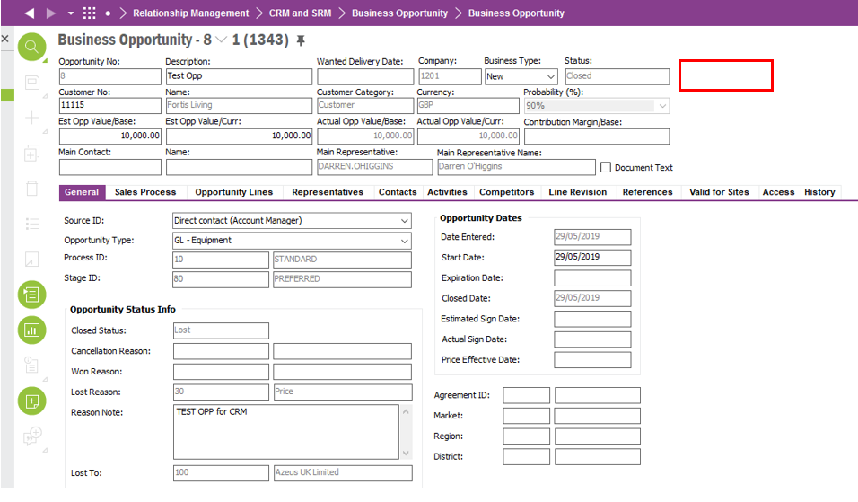

# Custom field on the Service Contract – Business Opportunity Reference

There must be a custom field on the Service Contract screen named, “Business Opportunity Reference”. This field will contain a Business Opportunity ID that is linked to the Service Contract. The custom field must be located in the Service Contract header in the top right (see red box on screenshot below).

The field must be automatically populated with the Business Opportunity ID when the Service Contract is created from the Business Opportunity screen with the RMB “Create Service Contract” 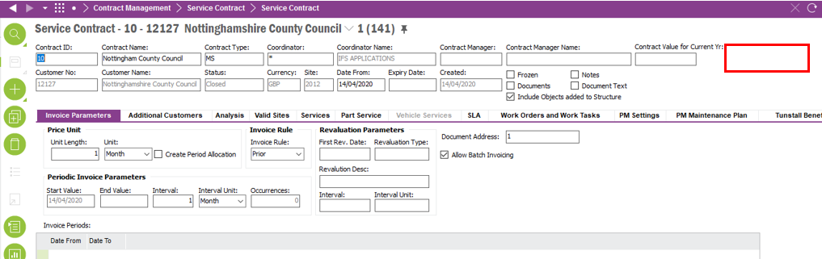

# Event to convert Business Opportunity to Won when a Service Contract is changed to status Active .

An event must take place that automatically closes the linked Business Opportunity (Service Contract’s “Business Opportunity Reference” field), if the Service Contract is moved to Status “Active”

The event will close the linked Business Opportunity as won with the reason “100” “Service Contract Won”. See the above section “3. Custom field on the Service Contract – Business Opportunity Reference” for details around this field. The below screenshot shows the Service Contract Status and where the Business Opportunity Reference field will be located in the Service Contract screen.

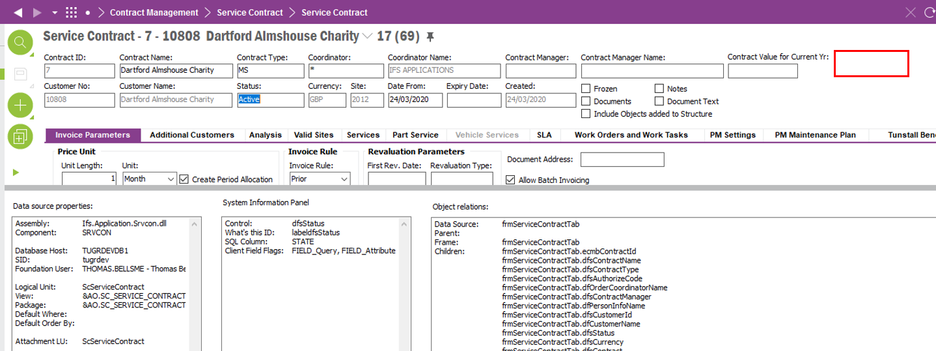

**Technical.**

Field Definitions.

<New Field/CLU Definition>

|  |  |  |  |  |  |  |
| --- | --- | --- | --- | --- | --- | --- |
| New DB Object Name | DB Object Item/Field Names | Item Description | Item Data Type | Item Syntax | Calculation Spec, if Derived | LOVs/Enums/Is Mandatory? |
|  |  |  |  |  |  |  |
|  |  |  |  |  |  |  |
|  |  |  |  |  |  |  |
|  |  |  |  |  |  |  |
|  |  |  |  |  |  |  |
|  |  |  |  |  |  |  |
|  |  |  |  |  |  |  |
|  |  |  |  |  |  |  |
|  |  |  |  |  |  |  |
|  |  |  |  |  |  |  |
|  |  |  |  |  |  |  |
|  |  |  |  |  |  |  |

Security

<Define security controls> (Who needs access to this and will it be restricted from any other users etc)

Companies

Applies to the following companies. All.

|  |  |
| --- | --- |
| **Company** | **Required (Y/N)** |
| 1201 | Y |
| TBC |  |
|  |  |

Data Migration

<Describe any data migration impacts this development may have – i.e additional data to be migrated>

Test Steps

<Steps that needs to be taken to test this change. Please provide expected results> Updated post solution.

|  |  |  |
| --- | --- | --- |
| **No** | **Script\Test Steps** | **Expected Result** |
|  | Attempt to close an opportunity as with closed status WON, if by closing opportunity does not convert the opportunity in the follow: Sales Quotations, Service Quotations, Sales Contracts or Customer orders in IFS. | The system will error.  Or the “Closed Status: Won” will not be selectable. |
|  |  |  |

Technical Implementation

<Completed by the technical developer - Technical solution, list packages, functions, Custom menus created etc >

**Package**

EA_CRM

**Users Permission granted**

IFS_ALL

**Custom Menus**

Business Opportunity Window

**Custom Fields**

Business Opportunity Window

Note: If the custom filed is not available on the layout, RMB on the header, Object Properties and add the Service Contract Custom Field to the layout. Make sure the two highlighted tick boxes are ticked.

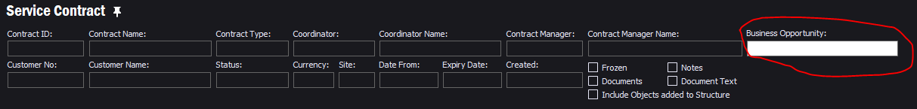Service Contract Window

Note: If the custom filed is not available on the layout, RMB on the header, Object Properties and add the Business Opportunity Custom Field to the layout. Make sure the two highlighted tick boxes are ticked.

**Custom Events**

